Georgia State Parks and Historic Sites
Weekly Summary

Crowds:
- Higher temperatures continue to impact day-use visitation at some sites. Sites that had to temporarily limit day use access due to capacity include: Cloudland Canyon, Red Top Mountain and Tugaloo. Fort McAllister’s boat ramp was not quite as busy but did reach capacity and had to use day-use parking. Golf continues to increase, 38% over last year. Highland Walk had their 3rd best day of the year on Saturday - 130 rounds played and $4,600 in revenue.

Staffing issues:
- As of Monday, the Division has 21 part-time and full-time staff out due to COVID-19 related reasons. 67 employees have been tested for COVID-19, 8 positives, 52 negatives, and 7 awaiting results.
- Several sites have severe vacancies, and some sites with staff out due to COVID-19 including Gordonia, Little White House, Red Top Mountain, Skidaway, Tallulah Gorge, Tugaloo, and Wormsloe.
- A campground guest at Skidaway, informed the park office that she was departing early due to her husband testing positive for COVID-19. The office was thoroughly sanitized once the guest had departed the office building.

Positives:
- Watson Mill’s equestrian bath house was installed Friday July 31st. This is a CXT structure and the three pieces were set in place with a crane. Final hook-up and grounds work will take place over the next two weeks. Pictures and videos were placed on Watson Mill’s Facebook page.
- Victoria Bryant received many great comments on the newly opened driving range cart path.
- At Smithgall, the Lodge Wi-Fi is being updated, adding streaming to TVs.
- Air conditioners were added to the Yurts at High Falls which should boost summer rentals. A Facebook post highlighting new air conditioners in yurts at High Falls was extremely popular on Facebook and was shared 200 times.
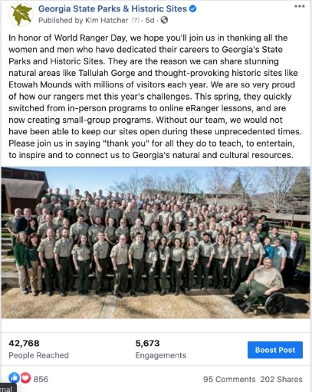
- July 31th was World Ranger Day, a day to celebrate Park Rangers around the world that have been injured or killed in the line of duty and to celebrate the great work that Park Rangers do to protect natural and cultural resources. A recent post for World Ranger Day reached over 40,000 people and had almost 100 comments complimenting Georgia Park Rangers.

- Reed Bingham will host the second Special Opportunity Alligator Quota Hunt beginning 8/16/2020. Reed Bingham experienced another great submission this year. From the 85 tags, 29 applied for the opportunity and 14 were selected. It is our hope to see a 100% success rate this year.
- Resource Management Unit began the large-scale task of treating a tall and dense stand of undesirable sweetgums at AH Stephens SP. This is a high-priority project to restore a high-visibility habitat. The 5.5 acres is very dense and most of the work has to be completed by hand.
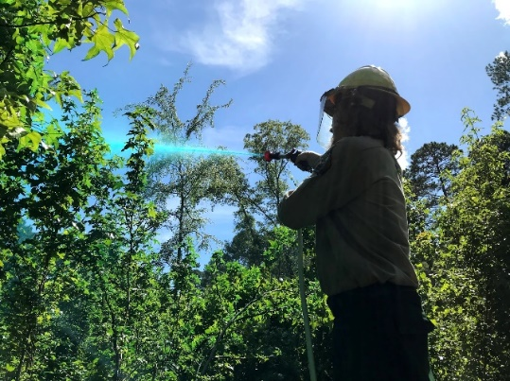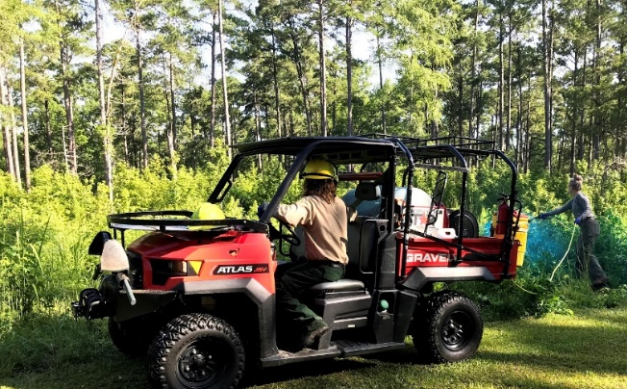

- The Installation/ repair of the siphon drainage system at Lake Buncombe is complete at A.H. Stephens. The previous system broke and the lake was so low the boat ramp was closed. With the new system installed it won’t be long before the boat ramp is reopened.
- Many sites, including Historic Sites that were experiencing lower visitation, have seen visitation return to more normal levels. Some sites such as Ft. Yargo are noticing park visitors are social distancing better than in recent months, including in the beach area. Other sites like Ft. McAllister and Tugaloo however, continue to have campers congregating together.
- Archaeology Unit met with Engineering and Construction to streamline cultural resource compliance.
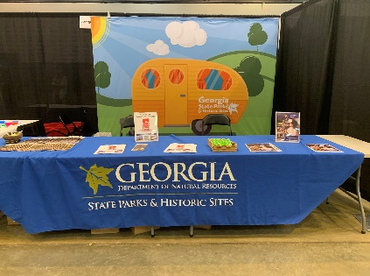
- Staff attended the annual Homeschool Expo tradeshow in Atlanta, which was a great opportunity for Georgia State Parks and Historic Sites to engage with thousands of homeschool families and their communities around the Atlanta area. Staff promoted Ranger led homeschool programs, customizable curriculum packages for groups, and our parks and sites as excellent field trips and learning locations around the state. The event was very successful considering the limitations during the pandemic with estimated attendance between 1300-1800 families over the course of two days. We received positive feedback from booth visitors, many stating how often they had been to our parks recently.
- Cloudland Canyon is in the 3rd week of refacing the park boundaries with the help of the Resource Management Unit. Also summer has seen increased visitation and despite the increased usage, the park looks great and staff morale is high.
- Coastal sites prepared for Hurricane Isaias and were thankful the hurricane did not hit Georgia.
- Crooked River’s new pollinator meadow is coming together nicely and is almost completed thanks to the park’s Interpretive Ranger and Friends group. Although the hurricane went north, the site still had some minor debris, tree limbs, etc. to remove.
- The Division utilized the weather alerts page for the first time this year for Hurricane Isaias. Facebook engagement and web traffic continues to be high with 8,572 pageviews of the Alerts Page this past week, and YTD- 555,492; the reservations page – pageviews were up 89% YoY; and total Pageviews up 59% YoY.
- Ft. King George has started the planning process for the tricentennial celebration of the founding of Fort King George (300 years) - which will be July of 2021.
- At Skidaway, major progress is being made in regards to the construction of the new visitors center. The exterior is completely framed out and the boarding process is almost complete.

Challenges
- Sites are receiving information that schools have “no field trip policies” in place due to COVID-19. This will impact fall visitation and revenue throughout the state, particularly at Historic Sites. Hopefully Homeschoolers will be interested in field trips.
- With Game Wardens busy with summer lake activity and other assignments, Cloudland Canyon has had less presence and has had a challenge with social distancing, proper trail usage, waterfall entry and maintaining a clear roadside at the entrance.
- Elijah Clark had severe Monday night which took down trees, power poles and power lines. A joint effort with park staff, campground hosts and Rayle EMC had all issues repaired before 8AM the next morning. The same storm caused down tree limbs in the Campground at George L. Smith. One pop-up camper was struck by a falling limb receiving minimal damage.
- Some Campground Hosts are still canceling with little or no notice including a Host scheduled to arrive at Ft. McAllister Saturday and canceled Friday. The site was able to quickly find a replacement.
- Cottage turnovers and housekeeping vacancies continue to be a challenge at a number of sites. At Ft. Yargo, the number of overnight turnovers (18 on Friday and another 14 on Sunday) require all hands on deck to turn the cottages.
- At Gordonia, a vehicle was found abandoned where it had hit a tree, which was reported and being investigated by local law enforcement.
- Hardman Farm has had to reduce tours due to Staff and Docents out due to COVID.
- Panola Mountain had a guest theft complaint in the pioneer campground over the weekend and worked with Rockdale county SO and LED on this issue.
- LED issued citations at Tallulah for visitors on gorge floor as permits are not being issued at this time.

Financial update

Past Weekend:
Overall occupancy for all reservables significantly increased this past weekend by 10% to 69%. Camping continues to see a significant increase, improving 14% to 79% occupancy. Cottage occupancy also saw an improvement by 3% to 88%. Yurt occupancy remained the same as last year at 94% occupancy. This is the 1st weekend we have seen cottage occupancy improve in a month.

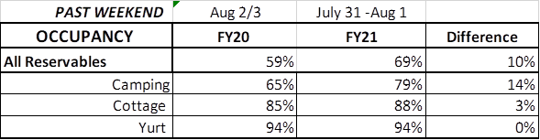
Upcoming Weekend:
For the upcoming weekend, there is a 7% increase in all reservables at 64% occupancy. Camping is showing a 9% increase, cottages are seeing an increase by 8%, but yurts are showing a 1% drop down to 94%.
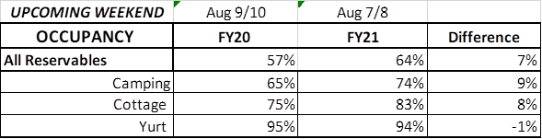
Revenue:
For FY21, YTD through July 31st, park receipts have decreased 2% or $52,000, although revenue increased for the 2nd week in a row.
For overnight accommodations – camping revenue continues to significantly increase. This past week camping revenue improved 41% or $87,000. Cottage revenue also saw an improvement, increasing 19% or $39,000. Yurts improved 11%.
For July 27th thru August 2nd, ParkPass revenue increased 20% or $22,000 compared to last year.
Golf once again had a significant increase at 38% or $13,000.
Historic site admissions did decline in comparison to last year, but only by 6% or $3,000.
